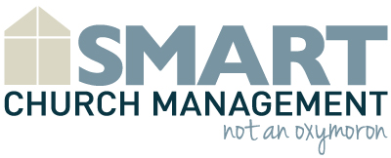

ABC Community Church
Church Member Satisfaction Survey
Please circle the number that corresponds with your level of agreement.
Strongly Disagree = 1 Disagree = 5 Strongly Agree = 10

1. Overall, I am satisfied as a member of ABC Church. | 1 2 3 4 5 6 7 8 9 10
2. ABC Church cares about its members. | 1 2 3 4 5 6 7 8 9 10
3. I receive the information I need regarding church projects and decisions. | 1 2 3 4 5 6 7 8 9 10
4. I have a good understanding of the mission and vision of ABC Church. | 1 2 3 4 5 6 7 8 9 10
5. ABC Church meets the spiritual needs of its members. | 1 2 3 4 5 6 7 8 9 10
6. I understand the process of becoming a church volunteer. | 1 2 3 4 5 6 7 8 9 10
7. I feel like I am part of a team helping to fulfill the mission of ABC Church. | 1 2 3 4 5 6 7 8 9 10
8. ABC Church is welcoming to visitors and new church members. | 1 2 3 4 5 6 7 8 9 10
9. I believe our mission and vision drive church decisions. | 1 2 3 4 5 6 7 8 9 10
10. I am provided opportunities for spiritual growth and leadership. | 1 2 3 4 5 6 7 8 9 10
11. I believe ABC Church cares about the spiritual development of my family. | 1 2 3 4 5 6 7 8 9 10
12. I intend to continue my membership at ABC Church. | 1 2 3 4 5 6 7 8 9 10
13. Please tell us one thing ABC Church could do to better achieve its mission.

Comments: ________________________________________________________________________________________________________________________________________________________________________________________________________________________________________________________________________________________________________________________________________________________________________________________________________________________________________________________

