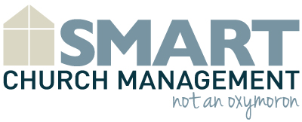

ABC Community Church
Meeting Agenda
7:00 pm | Welcome/Prayer | Pastor Steve
7:05 pm | Goal of Meeting | Pastor Steve
7:10 pm | Speaker Introduction | Pastor Steve
7:15 pm | Content Presentation (you can insert example meeting goals here) | John Smith
8:00 pm | Questions/Answers | John Smith/Pastor Steve
8:15 pm | Other Business (updates on previous agenda items) | Pastor Steve
8:25 pm | Close in prayer | Pastor Steve
8:30 pm | Fellowship/Refreshments

