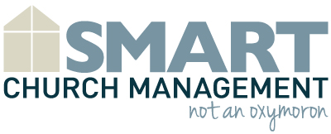
ABC Community Church
First Time Visitor Survey
Thank you for visiting ABC Community Church. We are glad you are here today! Please answer a few questions for us and drop it in the offering bucket or with the usher as you leave church.
Name: | Address:
Phone: | Email:
How did you hear about our church? | Friend/Family  Internet Search/Website  I Live Nearby  Other
Was this your first time visiting? | Yes No
Which service did you attend? | 7:00 am  9:00 am  11:00 am
Do you have children? | Yes No  If yes,  How many boys? ______  What are their ages? ______  How many girls? ______  What are their ages? ______
Would you like more information about the church? | Yes No
May we contact you by email? | Yes No
Do you have a prayer request? | Yes No  If yes, please describe.
Thank you for visiting ABC Community Church. We look forward to your next visit!

